# VIRTUAL MOUSE CONTROL WITH EYE BALL MOVEMENTS USING OPENCV

#### Submitted in partial fulfilment of the requirements for the award of Bachelor of Engineering Degree in

**Electronics and Communication Engineering**

**By**

**Ram Nivas Anusuri (39130030)**

**B.D.R.V. Nageswara Rao (39130064)**

**DEPARTMENT OF ELECTRONICS AND COMMUNICATION ENGINEERING**

#### SCHOOL OF ELECTRICAL AND ELECTRONICS

**SATHYABAMA INSTITUTE OF SCIENCE AND TECHNOLOGY**

(DEEMED TO BE UNIVERSITY)

**Accredited with Grade “A” by NAAC**

**JEPPIAAR NAGAR, RAJIV GANDHI SALAI, CHENNAI - 600119.**

#### JANUARY 2023

**SATHYABAMA** **INSTITUTE OF SCIENCE AND TECHNOLOGY**

**(DEEMED TO BE UNIVERSITY)**

**Accredited with Grade “A” by NAAC**

**JEPPIAAR NAGAR, RAJIV GANDHI SALAI, CHENNAI - 600 119**

**[www.sathyabama.ac.in](http://www.sathyabama.ac.in)**

DEPARTMENTOF ELECTRONICS AND COMMUNICATION ENGINEERING

**BONAFIDE CERTIFICATE**

This is to certify that that this Project Report is the bonafide work of **Ram Nivas Anusuri** **(39130030)** and **B.D.R.V. Nageswara Rao** **(39130064)** who carried out the project entitled **“VIRTUAL MOUSE CONTROL WITH EYE BALLMOVEMENTS USING OPENCV”** supervision from NOVEMBER 2022 to MARCH 2023.

Internal Guide

**Dr. G. D. Anbarasi Jebaselvi., M.E., Ph. D**

Head of the Department

**Dr. T. RAVI, M.E., Ph.D.**

**Submitted for Viva voce Examination held on**

**Internal Examiner External Examiner**

**DECLARATION**

We, **Ram Nivas Anusuri (39130030)** **and B.D.R.V. Nageswara Rao (39130064)**, hereby declare that the Project Report entitled “**VIRTUAL MOUSE CONTROL WITH EYE BALL MOVEMENTS USING OPENCV”** is done under the guidance of**, Dr. G. D. Anbarasi Jebaselvi,** is submitted in partial fulfilment of the requirements for the award of Bachelor of Engineering degree in **Electronics and Communication Engineering.**

1. 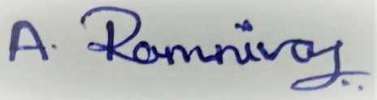

**2.**

**SIGNATURE OF THE CANDITATES**

**DATE:**

**PLACE:**

**ACKNOWLEDGEMENT**

We are pleased to acknowledge our sincere thanks to Board of Management of **SATHYABAMA INSTITUTE OF SCIENCE AND TECHNOLOGY** for their kind encouragement in doing this project and for completing it successfully. We are grateful to them.

We convey our profound gratitude to **Dr. N.M. NANDHITHA, M.E., Ph.D**., Prof. & Dean, School of Electrical and Electronics and **Dr. T. RAVI, M.E., Ph.D.,** Head of the Department of **Electronics and Communication Engineering**, Sathyabama University for having been a constant source of support and encouragement for the completion of the project.

We consider our self-most fortunate and immensely privileged to have worked under the guidance of **Dr. G. D. Anbarasi Jebaselvi, M.E., Ph.D.,** Department of Electronics and Communication Engineering to complete this project successfully.

WE express our heartfelt thanks to our family members and all our friends who helped me to complete our project successfully and finally, I thank the exciting Super Natural Power, the Almighty GOD.

**TABLE OF CONTENTS**

|  |  |  |
| --- | --- | --- |
| **CHAPTER** | **TITLE** | **PAGE NO.** |
|  | **ABSTRACT** | 1 |
| **1.** | **INTRODUCTION** | 4 |
| **2.** | **LITERATURE SURVEY** | 18 |
|  | **2.1**Hand Gesture Recognition Based Virtual Mouse Events | 18 |
|  | 2.2 Virtual Mouse Control Using Coloured Finger Tips and Hand Gesture Recognition | 18 |
|  | 2.3 Mouse on a Ring: A Mouse Action Scheme Based on IMU and Multi-Level Decision Algorithm | 18 |
|  | 2.4 Wireless Gyro-mouse for Text Input on a Virtual Keyboard | 19 |
|  | **2.5** Gesture Recognition Based Virtual Mouse and Keyboard | 19 |
| **3.** | **EXISTING SYSTEM** | 20 |
| **4.** | **PROPOSED SYSTEM** | 21 |
|  | 4.1 Deep Neural Network | 22 |
|  | 4.2 Deep Neural Network methodology | 23 |
|  | 4.3 Linear Discriminator | 23 |
| **5.** | **SOFTWARE AND ALGORITHMS USED** | 29 |
| **6.** | **CONCLUSION** | 30 |
|  | **REFERENCES** | 31 |

**ABSTRACT**

There are different reasons for which people need an artificial of locomotion such as a virtual keyboard.  The number of people, who need to move around with the help of some article means, because of an illness. Moreover, implementing a controlling system in it enables them to move without the help of another person is very helpful. The idea of eye controls of great use to not only the future of natural input but more importantly the handicapped and disabled. Camera is capturing the image of eye movement. First detect pupil centre position of eye. Then the different variation on pupil position get different command set for virtual keyboard.  The signals pass the motor driver to interface with the virtual keyboard itself.  The motor driver will control both speed and direction to enable the virtual keyboard to move forward, left, right and stop.

**ABBREVIATIONS**

* Human-Computer Interface (HCI)
* Automatic Speech Recognition (ASR)
* Machine Learning (ML)
* Support Vector Regression (SVR)
* Principal Component Analysis (PCA)
* Information Extraction (IE)
* Linear discriminant analysis (LDA)
* Analysis of Variance (ANOVA)
* Artificial neural networks (ANN)
* Support vector machine (SVM)

**LIST OF FIGURES**

|  |  |  |
| --- | --- | --- |
| **FIG.** | **TITLE** | **PAGE NO.** |
| 4.1 | Deep neural network | 22 |
| 4.2 | Graph of dataset | 24 |
| 4.3 | LDA: Projection on X-Axis | 24 |
| 4.4 | Dimensionality Reduction | 25 |
| 4.5 | Linear Discriminant Analysis in Python | 25 |
| 4.6 | Minimizing variance | 26 |
| 4.7 | LDA: Better Output | 26 |
| 4.8 | Block Diagram | 27 |

## ****CHAPTER 1****

## ****INTRODUCTION****

## **As** the computer technologies are growing rapidly, the importance of human computer interaction becomes highly notable. Some persons who are disabled cannot be able to use the computers. Eye ball movement control mainly used for disabled people. Incorporating this eye controlling system with the computers will make them to work without the help of other individual. Human-Computer Interface (HCI) is focused on use of computer technology to provide interface between the computer and the human. There is a need for finding the suitable technology that makes the effective communication between human and computer. Human computer interaction plays the important role. Thus, there is a need to find a method that spreads an alternate way for making communication between the human and computer to the individuals those who have impairments and give them an equivalent space to be an element of Information Society. In recent years, the human computer interfaces are attracting the attention of various researchers across the globe. Human computer interface is an implementation of the vision-based system for eye movement detection for the disabled people in the proposed system, we have included the face detection, face tracking, eye detection and interpretation of a sequence of eye blinks in real time for controlling a nonintrusive human computer interface. Conventional method of interaction with the computer with the mouse is replaced with the human eye movements. This technique will help the paralyzed person, physically challenged people especially person without hands to compute efficiently and with the ease of use. Firstly, camera captures the image and focuses on the eye in the image using OpenCV code for pupil detection. This results the centre position of the human eye (pupil). Then the centre position of the pupil is taken as a reference and based on that the human or the user will control the cursor by moving left and right. This paper organization is described as follows. Section II describes existing solutions to find the cursor movement using some 3D models. We present how cursor is working based only on Eyeball movement using OpenCV methodology. In how the cursor is moving using eyeball with example with the better solutions. And the Conclusion part are presented.

**1.1 MACHINE LEARNING – OVERIEW**

Machine learning is a very hot topic for many key reasons, and because it provides the ability to automatically obtain deep insights, recognize unknown patterns, and create high performing predictive models from data, all without requiring explicit programming instructions.

This high-level understanding is critical if ever involved in a decision-making process surrounding the usage of machine learning, how it can help achieve business and project goals, which machine learning techniques to use, potential pitfalls, and how to interpret the results.

Machine learning is a subfield of computer science, but is often also referred to as predictive analytics, or predictive modelling. Its goal and usage are to build new and/or leverage existing algorithms to learn from data, in order to build generalizable models that give accurate predictions, or to find patterns, particularly with new and unseen similar data.

Imagine a dataset as a table, where the rows are each observation (aka measurement, data point, etc), and the columns for each observation represent the features of that observation and their values.

At the outset of a machine learning project, a dataset is usually split into two or three subsets. The minimum subsets are the training and test datasets, and often an optional third validation dataset is created as well.

Once these data subsets are created from the primary dataset, a predictive model or classifier is trained using the training data, and then the model’s predictive accuracy is determined using the test data.

As mentioned, machine learning leverages algorithms to automatically model and find patterns in data, usually with the goal of predicting some target output or response. These algorithms are heavily based on statistics and mathematical optimization.

Optimization is the process of finding the smallest or largest value (minima or maxima) of a function, often referred to as a loss, or cost function in the minimization case. One of the most popular optimization algorithms used in machine learning is called gradient descent, and another is known as the normal equation.

In a nutshell, machine learning is all about automatically learning a highly accurate predictive or classifier model, or finding unknown patterns in data, by leveraging learning algorithms and optimization techniques.

# MACHINE LEARNING APPLICATIONS

As we move forward into the digital age, one of the modern innovations we’ve seen is the creation of **Machine Learning**. This incredible form of artificial intelligence is already being used in various industries and professions. For Example, Image and Speech Recognition, Medical Diagnosis, Prediction, Classification, Learning Associations, Statistical Arbitrage, Extraction, Regression. Today we’re looking at all these Machine Learning Applications in today’s modern world.

**1.2.1 IMAGE RECOGNITION**

It is one of the most common machine learning applications. There are many situations where you can classify the object as a digital image. For digital images, the measurements describe the outputs of each pixel in the image.

In the case of a **black and white image**, the intensity of each pixel serves as one measurement. So, if a black and white image has N*N pixels, the total number of pixels and hence measurement is N2.

In the **coloured image**, each pixel considered as providing 3 measurements of the intensities of 3 main colour components i.e. **RGB**. So, N*N coloured image there are 3 N2 measurements.

* **For face detection –** The categories might be face versus no face present. There might be a separate category for each person in a database of several individuals.
* **For character recognition** – We can segment a piece of writing into smaller images, each containing a single character.  The categories might consist of the 26 letters of the English alphabet, the 10 digits, and some special characters.

**1.2.2 Speech Recognition**

**Speech recognition (SR)** is the translation of spoken words into text. It is also known as “automatic speech recognition” (ASR), “computer speech recognition”, or “speech to text” (STT).

In speech recognition, a software application recognizes spoken words. The measurements in this Machine Learning application might be a set of numbers that represent the speech signal. We can segment the signal into portions that contain distinct words or phonemes. In each segment, we can represent the speech signal by the intensities or energy in different time-frequency bands.

Although the details of signal representation are outside the scope of this program, we can represent the signal by a set of real values.

Speech recognition, Machine Learning applications include voice user interfaces. Voice user interfaces are such as voice dialling, call routing, demotic appliance control. It can also use as simple data entry, preparation of structured documents, speech-to-text processing, and plane.

**1.2.3 Medical Diagnosis**

ML provides methods, techniques, and tools that can help in solving diagnostic and prognostic problems in a variety of medical domains. It is being used for the analysis of the importance of clinical parameters and of their combinations for prognosis, e.g. prediction of disease progression, for the extraction of medical knowledge for outcomes research, for therapy planning and support, and for overall patient management. ML is also being used for [**data analysis**](http://data-flair.training/blogs/data-analytics-comprehensive-guide/), such as detection of regularities in the data by appropriately dealing with imperfect data, interpretation of continuous data used in the Intensive Care Unit, and for intelligent alarming resulting in effective and efficient monitoring.

It is argued that the successful implementation of ML methods can help the integration of computer-based systems in the healthcare environment providing opportunities to facilitate and enhance the work of medical experts and ultimately to improve the efficiency and quality of medical care.

In medical diagnosis, the main interest is in establishing the existence of a disease followed by its accurate identification. There is a separate category for each disease under consideration and one category for cases where no disease is present. Here, machine learning improves the accuracy of medical diagnosis by analysing data of patients.

The measurements in this Machine Learning applications are typically the results of certain medical tests (example blood pressure, temperature and various blood tests) or medical diagnostics (such as medical images), presence/absence/intensity of various symptoms and basic physical information about the patient (age, sex, weight etc). On the basis of the results of these measurements, the doctors narrow down on the disease inflicting the patient.

**1.2.4 Statistical Arbitrage**

In finance, statistical arbitrage refers to automated trading strategies that are typical of a short-term and involve a large number of securities. In such strategies, the user tries to implement a trading algorithm for a set of securities on the basis of quantities such as historical correlations and general economic variables. These measurements can be cast as a classification or estimation problem. The basic assumption is that prices will move towards a historical average.

We apply machine learning methods to obtain an index arbitrage strategy. In particular, we employ linear regression and **support vector regression (SVR)** onto the prices of an exchange-traded fund and a stream of stocks. By using **principal component analysis (PCA)** in reducing the dimension of feature space, we observe the benefit and note the issues in the application of SVR. To generate trading signals, we model the residuals from the previous regression as a mean reverting process.

In the case of classification, the categories might be sold, buy or do nothing for each security. I the case of estimation one might try to predict the expected return of each security over a future time horizon. In this case, one typically needs to use the estimates of the expected return to make a trading decision (buy, sell, etc.)

# 1.2.5 Learning Associations

Learning association is the process of developing insights into various associations between products. A good example is how seemingly unrelated products may reveal an association to one another. When analysed in relation to buying behaviours of customers.

One application of machine learning- Often studying the association between the products people buy, which is also known as basket analysis. If a buyer buys ‘X’, would he or she force to buy ‘Y’ because of a relationship that can identify between them?  This leads to the relationship that exists between fish and chips etc.  when new products launch in the market a Knowing these relationships it develops a new relationship.  Knowing these relationships could help in suggesting the associated product to the customer. For a higher likelihood of the customer buying it, it can also help in bundling products for a better package.

This learning of associations between products by a machine is learning associations. Once we found an association by examining a large amount of sales data, [**Big Data**](http://data-flair.training/blogs/why-learn-big-data-use-cases/) analysts. It can develop a rule to derive a probability test in learning a conditional probability.

# 1.2.6 Classification

**Classification** is a process of placing each individual from the population under study in many classes. This is identified as independent variables.

Classification helps analysts to use measurements of an object to identify the category to which that object belongs. To establish an efficient rule, analysts use data. Data consists of many examples of objects with their correct classification.

For example, before a bank decides to disburse a loan, it assesses customers on their ability to repay the loan. By considering factors such as customer’s earning, age, savings and financial history we can do it. This information is taken from the past data of the loan. Hence, Seeker uses to create a relationship between customer attributes and related risks.

# 1.2.7 Prediction

Consider the example of a bank computing the probability of any of loan applicants faulting the loan repayment. To compute the probability of the fault, the system will first need to classify the available data in certain groups. It is described by a set of rules prescribed by the analysts.

Once we do the classification, as per need we can compute the probability. These probability computations can compute across all sectors for varied purposes

The current prediction is one of the hottest machine learning algorithms. Let’s take an example of retail, earlier we were able to get insights like sales report last month / year / 5-years / Diwali / Christmas. This type of reporting is called as historical reporting. But currently business is more interested in finding out what will be my sales next month / year / Diwali, etc.  
So that business can take a required decision (related to procurement, stocks, etc.) on time.

**1.2.8 Extraction**

**Information Extraction (IE)** is another application of machine learning. It is the process of extracting structured information from unstructured data. For example, web pages, articles, blogs, business reports, and e-mails. The relational database maintains the output produced by the information extraction.

The process of extraction takes input as a set of documents and produces a structured data. This output is in a summarized form such as an excel sheet and table in a relational database.

Nowadays extraction is becoming a key in the big data industry.

As we know that the huge volume of data is getting generated out of which most of the data is unstructured. The first key challenge is handling unstructured data. Now conversion of unstructured data to structured form based on some pattern so that the same can stored in [RDBMS](https://data-flair.training/blogs/sql-rdbms/)**.**

Apart from this in current days data collection mechanism is also getting change. Earlier we collected data in batches like End-of-Day (EOD), but now business wants the data as soon as it is getting generated, i.e. in real time.

# 1.2.9 Regression

We can apply Machine learning to regression as well.

Assume that x= x1, x2, x3, … xn are the input variables and y is the outcome variable. In this case, we can use machine learning technology to produce the output (y) on the basis of the input variables (x). You can use a model to express the relationship between various parameters as below:

**Y=g(x)** where g is a function that depends on specific characteristics of the model.  
In regression, we can use the principle of machine learning to optimize the parameters. To cut the approximation error and calculate the closest possible outcome.

We can also use Machine learning for function optimization. We can choose to alter the inputs to get a better model. This gives a new and improved model to work with. This is known as response surface design.

So, this was all about Machine Learning Applications. Hope you like our explanation.

**1.3 MACHINE LEARNING – TASKS**

The **most common machine learning tasks** that one may come across while trying to solve a machine learning problem. Under each task are also listed a set of **machine learning methods** that could be used to resolve these tasks. Please feel free to comment/suggest if I missed mentioning one or more important points. Also, sorry for the typos.

Following are the key machine learning tasks briefed later in this article:

Feature selection

Regression

Classification

Clustering

Multivariate querying

Density estimation

Dimension reduction

Testing and matching

Following are top 8 most common machine learning tasks that one could come across most frequently while solving an advanced analytics problem:

**Feature Selection**: Feature selection is one of the critical tasks which would be used when building machine learning models. Feature selection is important because selecting right features would not only help build models of higher accuracy but also help achieve objectives related to building simpler models, reduce overfitting etc. The following are some of the techniques which could be used for feature selection:

Filter methods which helps in selecting features based on the outcomes of statistical tests. The following are some of the statistical tests which are used:

Pearson’s correlation

Linear discriminant analysis (LDA)

Analysis of Variance (ANOVA)

Chi-square tests

Wrapper methods which helps in feature selection by using a subset of features and determining the model accuracy. The following are some of the algorithms used:

Forward selection

Backward elimination

Recursive feature elimination

Regularization techniques which penalizes one or more features appropriately to come up with most important features. The following are some of the algorithms used:

LASSO (L1) regularization

Ridge (L2) regularization

**Regression**: Regression tasks mainly deal with estimation of numerical values (**continuous variables**). Some of the examples include estimation of housing price, product price, stock price etc. Some of the following ML methods could be used for solving regressions problems:

Kernel regression (Higher accuracy)

Gaussian process regression (Higher accuracy)

Regression trees

Linear regression

Support vector regression

LASSO

**Classification**: Classification tasks is simply related with predicting a category of a data (**discrete variables**). One of the most common examples is predicting whether or not an email if spam or ham. Some of the common use cases could be found in the area of healthcare such as whether a person is suffering from a particular disease or not. It also has its application in financial use cases such as determining whether a transaction is fraud or not. The ML methods such as following could be applied to solve classification tasks:

Kernel discriminant analysis (Higher accuracy)

K-Nearest Neighbours (Higher accuracy)

Artificial neural networks (ANN) (Higher accuracy)

Support vector machine (SVM) (Higher accuracy)

Random forests (Higher accuracy)

Decision trees

Boosted trees

Logistic regression

naive Bayes

Deep learning

**Clustering**: Clustering tasks are all about finding natural groupings of data and a label associated with each of these groupings (clusters). Some of the common example includes customer segmentation, product features identification for product roadmap. Some of the following are common ML methods:

Mean-shift (Higher accuracy)

Hierarchical clustering

K-means

Topic models

**Multivariate querying**: Multivariate querying is about querying or finding similar objects. Some of the following ML methods could be used for such problems:

Nearest neighbours

Range search

Farthest neighbours

**Density estimation**: Density estimation problems are related with finding likelihood or frequency of objects. In probability and statistics, density estimation is the construction of an estimate, based on observed data, of an unobservable underlying probability density function. Some of the following ML methods could be used for solving density estimation tasks:

Kernel density estimation (Higher accuracy)

Mixture of Gaussians

Density estimation tree

**Dimension reduction**: Dimension reduction is the process of reducing the number of random variables under consideration, and can be divided into feature selection and feature extraction. Following are some of ML methods that could be used for dimension reduction:

Manifold learning/KPCA (Higher accuracy)

Principal component analysis

Independent component analysis

Gaussian graphical models

Non-negative matrix factorization

Compressed sensing

**Testing and matching**: Testing and matching tasks relates to comparing data sets. Following are some of the methods that could be used for such kind of problems:

Minimum spanning tree

Bipartite cross-matching

N-point correlation

**1.4 MACHINE LEARNING SYSTEM CLASSIFICATION**

Although supervised and unsupervised learning are two of the most widely accepted machine learning methods by businesses today, there are various other machine learning techniques. Following is an overview of some of the most accepted ML methods.

**Supervised Learning**

These algorithms are trained using labelled examples, in different scenarios, as an input where the desired outcome is already known. An equipment, for instance, could have data points such as "F" and "R" where "F" represents "failed" and "R" represents "runs".

A learning algorithm will receive a set of input instructions along with the corresponding accurate outcomes. The learning algorithm will then compare the actual outcome with the accurate outcome and flag an error, if there is any discrepancy. Using different methods, such as regression, classification, gradient boosting, and prediction, supervised learning uses different patterns to proactively predict the values of a label on extra unlabelled data. This method is commonly used in areas where historical data is used to predict events that are likely to occur in the future. For instance, anticipate when a credit card transaction is likely to be fraudulent or predict which insurance customers are likely to file their claims.

**Unsupervised Learning**

This method of ML finds its application in areas were data has no historical labels. Here, the system will not be provided with the "right answer" and the algorithm should identify what is being shown. The main aim here is to analyse the data and identify a pattern and structure within the available data set. Transactional data serves as a good source of data set for unsupervised learning.

For instance, this type of learning identifies customer segments with similar attributes and then lets the business to treat them similarly in marketing campaigns. Similarly, it can also identify attributes that differentiate customer segments from one another. Either ways, it is about identifying a similar structure in the available data set. Besides, these algorithms can also identify outliers in the available data sets.

Some of the widely used techniques of unsupervised learning are -

* k-means clustering
* self-organizing maps
* value decomposition
* mapping of nearest neighbour

**Semi-supervised Learning**

This kind of learning is used and applied to the same kind of scenarios where supervised learning is applicable. However, one must note that this technique uses both unlabelled and labelled data for training. Ideally, a small set of labelled data, along with a large volume of unlabelled data is used, as it takes less time, money and efforts to acquire unlabelled data. This type of machine learning is often used with methods, such as regression, classification and prediction. Companies that usually find it challenging to meet the high costs associated with labelled training process opt for semi-supervised learning.

**Reinforcement Learning**

This is mainly used in navigation, robotics and gaming. Actions that yield the best rewards are identified by algorithms that use trial and error methods. There are three major components in reinforcement learning, namely, the agent, the actions and the environment. The agent in this case is the decision maker, the actions are what an agent does, and the environment is anything that an agent interacts with. The main aim in this kind of learning is to select the actions that maximize the reward, within a specified time. By following a good policy, the agent can achieve the goal faster.

## ****CHAPTER 2****

## ****LITERATURE SURVEY****

# ****2.1**** Hand Gesture Recognition Based Virtual Mouse Events

## This paper proposes a virtual mouse application based on the tracking of different hand gestures. The system eliminates the dependency on any external hardware required to perform mouse actions. A built-in camera tracks the user's hands, predefined gestures are recognized and the corresponding mouse events are executed. This system has been implemented in Python using OpenCV and PyAutoGUI. Researchers have studied background conditions, effects of differences in illuminance and skin colour individually. However, the proposed system aims to consider all the above factors to build an application most suitable in the real world.

# 2.2 Virtual Mouse Control Using Coloured Finger Tips and Hand Gesture Recognition

## 

## In human-computer interaction, virtual mouse implemented with fingertip recognition and hand gesture tracking based on image in a live video is one of the studies. In this paper, virtual mouse control using fingertip identification and hand gesture recognition is proposed. This study consists of two methods for tracking the fingers, one is by using coloured caps and other is by hand gesture detection.

# 2.3 Mouse on a Ring: A Mouse Action Scheme Based on IMU and Multi-Level Decision Algorithm

## The traditional mouse has been used as a main tool for human-computer interaction for more than 50 years. However, it has become unable to cater to people’s need for mobile offering and all-weather use due to its reliance on the support of a two-dimensional plane, poor portability, wearisomeness, and other problems. In this paper, they propose a portable ring-type wireless mouse scheme based on IMU sensors and a multi-level decision algorithm. The user only needs to operate in the air with a smart ring worn on the middle finger of their right hand to realize the interactive function of a mouse.

# 2.4 Wireless Gyro-mouse for Text Input on a Virtual Keyboard

## In this paper, we propose a gyroscopic pointing device that allows a user to type text by using a specialized virtual keyboard. We compare different typing methods that use the dwell time of the pointer as a character selection method. The proposed solution can be used in different applications, such as: computer gaming, virtual reality, remote control and to facilitate communication with people affected by certain disabilities and can easily accommodate more types of users.

# 2.5 Gesture Recognition Based Virtual Mouse and Keyboard

## Nowadays computer vision has reached its pinnacle, where a computer can identify its owner using a simple program of image processing. In this stage of development, people are using this vision in many aspects of day to day life, like Face Recognition, Colour detection, Automatic car, etc. In this project, computer vision is used in creating an Optical mouse and keyboard using hand gestures. The camera of the computer will read the image of different gestures performed by a person's hand and according to the movement of the gestures the Mouse or the cursor of the computer will move, even perform right and left clicks using different gestures. Similarly, the keyboard functions may be used with some different gestures, like using one finger gesture for alphabet select and four-figure gesture to swipe left and right.

**CHAPTER – 3**

## ****EXISTING SYSTEM****

## MATLAB detect the iris and control cursor. Eye movement-controlled wheel chair is existing one that controls the wheel chair by monitoring eye movement****.**** In MATLAB is difficult to predict the Centroid of eye so we go for OpenCV. The different eye-motions are classified with the help of support vector machine classifier. The eye-movements are eye open, eye close, eyeball left and eyeball right are captured by web camera. SVM can analyze data and used for classification and regression analysis. SVM is a set of associated supervised learning functions used for classification and regression problems. In SVM, the multi class file is used. This PIR sensor is connected to the General Purpose I/O port of the Raspbian board, it detects the eye pupil movement and hence makes the camera to start capturing the images. Sensor can cover the range up to 5cm.

## ****CHAPTER 4****

## ****PROPOSED SYSTEM****

## The Exact Position of The Pupil Is Known by Using Vertical Integral Projection and Horizontal Projection. These Projections Divide the Whole Picture to Homogenous Subsets. The Arbitrary Threshold Is Used in The Proposed Method. The Noise Can Be Removed by Using Gaussian Filter. The Strong Pixel Value Is Based on Minimum Gradient Point. The Lower Threshold Protects Against Splitting Edges in The Contrast Region. Circular Hough Transform Is Used for Finding the Inner and Outer Boundaries. Hough Transform Check All the Edge Points with Centre Coordinates.

**4.1 Deep Neural Network**

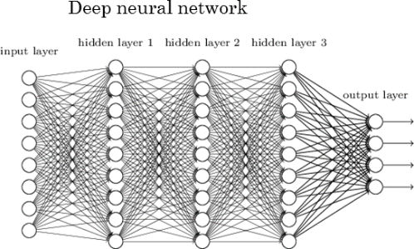

Fig.4.1 Deep neural network

Nodes are little parts of the system, and they are like neurons of the human brain. When a stimulus hits them, a process takes place in these nodes. Some of them are connected and marked, and some are not, but in general, nodes are grouped into layers.

The system must process layers of data between the input and output to solve a task. The more layers it has to process to get the result, the deeper the network is considered. There is a concept of Credit Assignment Path (CAP) which means the number of such layers needed for the system to complete the task. The neural network is deep if the CAP index is more than two.

A deep neural network is beneficial when you need to replace human labour with autonomous work without compromising its efficiency. The deep neural network usage can find various applications in real life. For example, a Chinese company [Sense time](https://www.sensetime.com/) created a system of automatic face recognition system to identify criminals, which uses real-time cameras to find an offender in the crowd. Nowadays, it has become a popular practice in police and other governmental entities.

The American company [Pony.ai](https://www.pony.ai/) is another example of how you can use DNN. They developed a system for AI cars that can work without a driver. It requires more than just a simple algorithm of actions, but a much deeper learning system, which should be able to recognize people, road signs and other markings like trees, and other important objects.

The famous company [UbiTech](https://ubtrobot.com/?ls=en) creates AI robots. One of their creations is the Alpha 2 robot that can live in a family, speak with its members, search for information, write messages, and execute voice commands.

**4.2 Deep Neural Network methodology**

The neural network needs to learn all the time to solve tasks in a more qualified manner or even to use various methods to provide a better result. When it gets new information in the system, it learns how to act accordingly to a new situation.

Learning becomes deeper when tasks you solve get harder. Deep neural network represents the type of machine learning when the system uses many layers of nodes to derive high-level functions from input information. It means transforming the data into a more creative and abstract component.

In order to understand the result of deep learning better, let's imagine a picture of an average man. Although you have never seen this picture and his face and body before, you will always identify that it is a human and differentiate it from other creatures. This is an example of how the deep neural network works. Creative and analytical components of information are analysed and grouped to ensure that the object is identified correctly. These components are not brought to the system directly, thus the ML system has to modify and derive them.

# 4.3 Linear Discriminator

Linear Discriminant Analysis (LDA) is a dimensionality reduction technique. As the name implies dimensionality reduction techniques reduce the number of dimensions (i.e. variables) in a dataset while retaining as much information as possible. For instance, suppose that we plotted the relationship between two variables where each colour represents a different class.

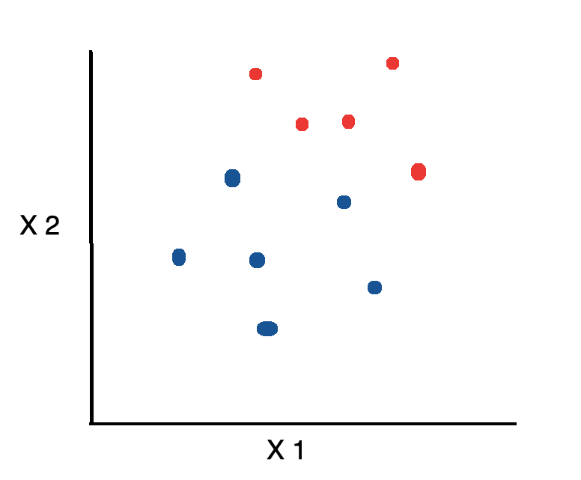

Fig.4.2 Graph of dataset

If we’d like to reduce the number of dimensions down to 1, one approach would be to project everything on to the x-axis.

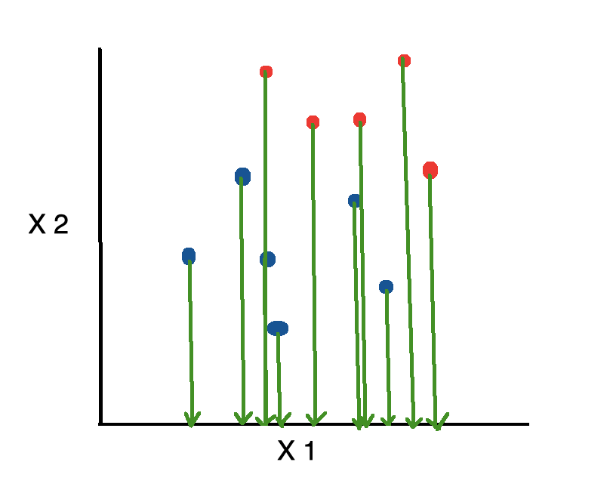

Fig.4.3 LDA: Projection on X-Axis

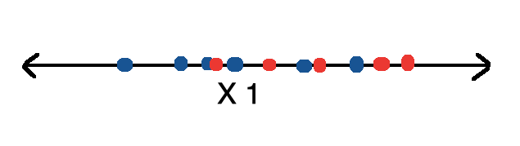

Fig.4.4 Dimensionality Reduction

This is bad because it disregards any useful information provided by the second feature. On the other hand, Linear Discriminant Analysis, or LDA, uses the information from both features to create a new axis and projects the data on to the new axis in such a way as to minimizes the variance and maximizes the distance between the means of the two classes.

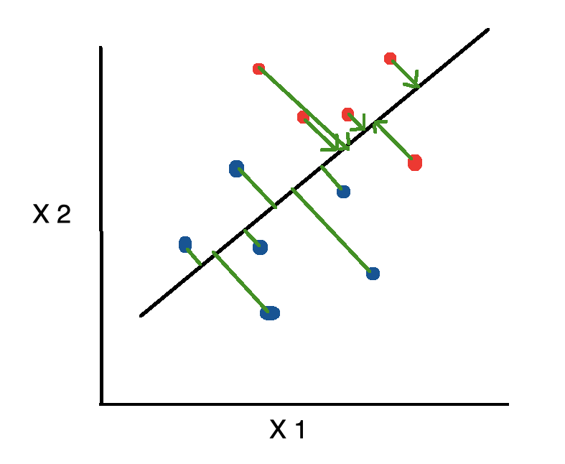

Fig.4.5 Linear Discriminant Analysis in Python

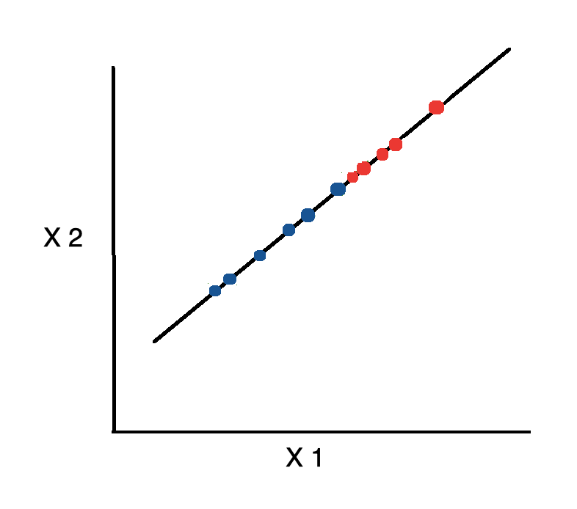

Fig.4.6 Minimizing variance

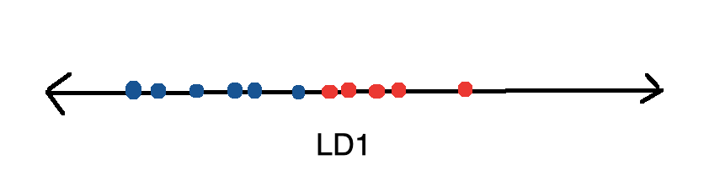

## **Fig.4.7 LDA: Better Output**

## ****BLOCK DIAGRAM****

Image Capturing

Face Detection

Eye Detection

Blink Detection

Eye Tracking

Face Detection

Click Event

Cursor Movement

Mouse Scrolling

Fig.4.8 Block diagram

The User Has to Sit In front Of the Display Screen of Private Computer or Pc, A Specialised Video Camera Established above the Screen to Study the Consumer’s Eyes. The Laptop Constantly Analysis the Video Photo of The Attention and Determines Wherein the Consumer Is Calling at The Display Screen. Not Anything Is attached to the Consumer’s Head or Body. To “Pick Out” Any Key, The User Seems at The Key for An Exact Period of Time and to “Press” Any Key, The Consumer Just Blink the Eye. On This Device, Calibration Procedure Is Not Required. For This System Enter Is Simplest Eye. No Outside Hardware Is Connected or Required. Camera Gets the Input from The Eye. After Receiving These Streaming Movies from the Cameras, it’ll spoil Into Frames. After Receiving Frames, It Will Check for Lights Conditions Because Cameras Require Enough Lighting Fixtures from External Sources in Any Other Case Blunders Message Will Show at The Screen. The Captured Frames Which Can Be Already in RGB Mode Are Transformed into Black ‘N’ White. Five. Pics (Frames) From the Enter Supply Focusing the Eye Are Analysed for Iris Detection (Middle of Eye). After this, A Mid-Point Is Calculated Through Taking the Suggest of Left and Right Eye Centre Point. Eventually the Mouse Will Pass from One position To Any Other at the Display and Consumer Will Perform Clicking with the Aid of Blinking Their Eyes for 5 Seconds.

## ****SOFTWARE REQUIREMENTS****

* Python
* OpenCV
* NumPy

**Python OpenCV**

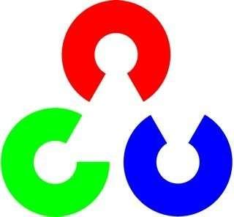OpenCV is a library of PC vision produced initially by Intel and now maintained by Willow Garage. It is safe to use under the license of the open source BSD. It's a cross platform library. For the most part, it centres around the preparation of the picture. If the library discovers the system's Integrated Performance Primitives, these business updated schedules will be used to speed it up. OpenCV isn't a piece of code that pictures are running and processing. You've got to write script.

## ****Algorithms****

## Auto encoded deep learning using CNN algorithm.

## Dataset esteems changed over into exhibit esteems which is going to give to the calculation to discover precision.

## Select the calculation dependent on the exactness and dissect the information by utilizing the calculation.

## ****ADVANTAGES****

* High accuracy
* physically handicapped people can operate computers

## ****CONCLUSION****

In this research, the experimental results provide objective eye-tracking evidence that confirms the hypotheses made based on the findings of existing research: Most students recognize beacons and pay more attention to these areas when debugging. Only significant statistical results have been reported in the conclusions, guaranteeing the conclusion validity. Previous research has revealed a relationship between working memory capacity and the cognitive activities related to debugging with regard to mental arithmetic, short-term memory, logical thinking, and problem solving. Thus, the eye ball movement tracking is applied to physically challenged peoples to obtain various results

## ****REFFERENCES****

[1].Brooks,R.E.(1997) ―Towards a theory of the cognitive processes in computer programming,‖ Int. J. Man-Mach. Studies, vol. 9, pp. 737–751.

[2].Cheng- Chih Wu, Ting-Yun Hou(2015)‖Tracking Students’ Cognitive Processes During Program Debugging‖—An Eye-Movement Approach, IEEE.

[3].Ehrlich,K. and Soloway,E.(1983) Cognitive strategies and looping constructs: An empirical study,‖ Commun. ACM, vol. 26, no. 11, pp. 853–860.

[4].Eric Sung and Jian-Gang Wang (2002)―Study on Eye Gaze Estimation‖, IEEE, VOL. 32, NO. 3, JUNE .

[5].Murphy,L. (2008)―Debugging: The good, the bad, and the quirky—A qualitative analysis of novices’ strategies,‖ SIGCSE Bull., vol. 40, no. 1, pp. 163–167.

[6].QiangJi and Zhiwei Zhu (2007)‖Novel Eye Gaze Tracking Techniques Under Natural Head Movement‖, Senior Member, IEEE, VOL. 54, NO. 12, DECEMBE